Node js will give npm amnd it is required for angular dev

So install nodejs first

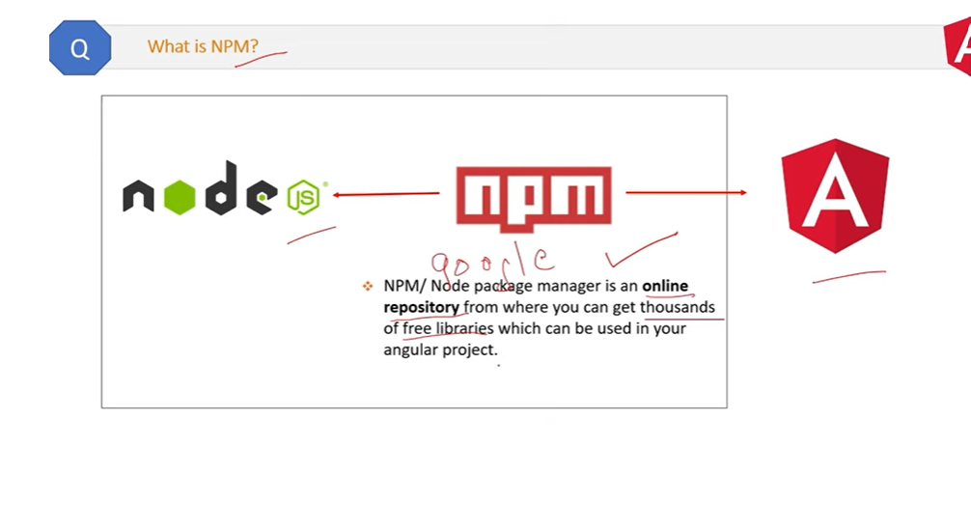

Selector identify each comp uniquely in comp tree

A template is html view pof component

Module-group comp pipe directive of application

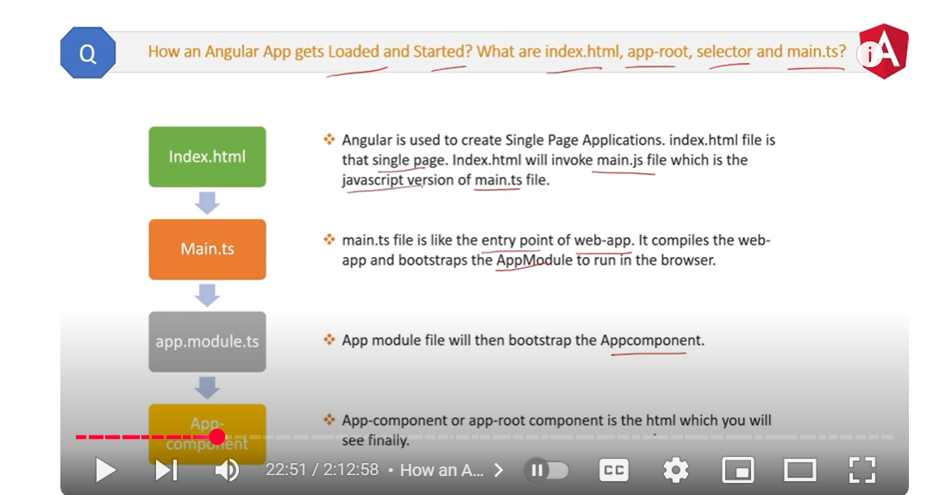

string interpolation works on only string not numbers

Property binding can deal with any datatype

Two way data binding-data flow in both side at the same time

Directives-classes that add additional behavour to elements in angular application.

Ngswitch-ngswitchcase and ngswitchwithdefault

Decorator stores metadata about class,method or property(represented with @symbol)

Example-selector,templateurl,styleurl is matadata in component decorator

Providedin r-root in service class means service is available throughout the application



When deciding between Angular and React, choose React if you prioritize flexibility, a simpler learning curve, and rapid development for smaller to medium-sized projects, while Angular is better suited for large, complex applications where a structured framework with built-in features is needed; essentially, React is more flexible and easier to learn, while Angular provides a more comprehensive and opinionated approach to development.

Key differences:

* **Flexibility:**

React offers greater flexibility to integrate with various libraries and customize components, while Angular provides a more structured approach with built-in features like routing and state management.

* **Learning Curve:**

React generally has a shallower learning curve due to its simpler syntax and component-based architecture compared to Angular's more complex structure.

* **Project Scope:**

For large, enterprise-level applications with complex requirements, Angular is often preferred due to its robust framework and features.

* **Data Binding:**

Angular uses two-way data binding, meaning changes in the UI automatically update the data model, while React uses one-way data binding, requiring explicit updates.

When to choose React:

Small to medium-sized projects, Rapid prototyping and development, Highly dynamic user interfaces with frequent updates, and Integrating with existing codebases.

When to choose Angular:

* Large-scale, complex applications
* Projects requiring a structured development approach
* Strong emphasis on maintainability and code organization
* Development teams with experience in TypeScript

When comparing React and Angular optimization, React generally performs better in terms of rendering speed and application responsiveness due to its virtual DOM mechanism, while Angular can optimize performance through features like change detection zones and tree-shaking, but can sometimes struggle with complex data binding scenarios that might impact performance, especially in large applications; making React a more flexible choice for dynamic UI updates and faster rendering in most cases.

Key Differences:

* **Virtual DOM:**

React utilizes a virtual DOM, which efficiently calculates the minimal necessary updates to the real DOM, leading to faster rendering, whereas Angular directly manipulates the real DOM.

* **Data Binding:**

React uses one-way data binding, where data flows from parent to child components, while Angular employs two-way data binding, which can sometimes lead to performance issues with complex data changes.

* **Change Detection:**

Angular uses a change detection mechanism with "zones" to track changes, which can be efficient for simple applications but can become less performant with complex data structures.

React Optimization Advantages:

* **Faster rendering:**

Virtual DOM allows for quick updates and minimal DOM manipulations, leading to a smoother user experience.

* **Component reusability:**

React's component-based architecture encourages code reuse and modularity, contributing to better performance and maintainability.

* **Flexibility:**

Developers have more control over when and how to re-render components, optimizing performance based on specific needs.

Angular Optimization Advantages:

* **Ahead-of-Time (AOT) compilation:**

Angular's AOT compilation can improve initial load times by pre-compiling TypeScript code into JavaScript.

* **Tree shaking:**

Eliminates unused code during the build process, resulting in smaller bundle sizes.

* **Structured architecture:**

Angular's MVC-like structure can provide better organization and maintainability for large projects.

Overall:

* **For most scenarios, especially with dynamic UI updates and frequent data changes, React is often preferred due to its virtual DOM performance benefits** .
* **If you need a highly structured framework with strong change detection mechanisms and prioritizes initial load time, Angular might be a better choice** .